%3CmxGraphModel%3E%3Croot%3E%3CmxCell%20id%3D%220%22%2F%3E%3CmxCell%20id%3D%221%22%20parent%3D%220%22%2F%3E%3CmxCell%20id%3D%222%22%20value%3D%22Use%22%20style%3D%22endArrow%3Dopen%3BendSize%3D12%3Bdashed%3D1%3Bhtml%3D1%3BentryX%3D0%3BentryY%3D0.5%3BentryDx%3D0%3BentryDy%3D0%3B%22%20edge%3D%221%22%20parent%3D%221%22%3E%3CmxGeometry%20width%3D%22160%22%20relative%3D%221%22%20as%3D%22geometry%22%3E%3CmxPoint%20x%3D%22210%22%20y%3D%22180%22%20as%3D%22sourcePoint%22%2F%3E%3CmxPoint%20x%3D%22350%22%20y%3D%2275%22%20as%3D%22targetPoint%22%2F%3E%3C%2FmxGeometry%3E%3C%2 Module-1(Fundamental)

**(A). what is SDLC?**

**-**SDLC is a series of steps or phases provides model of development. It is a life cycle management for piece of software or application.

**(B). what is software testing?**

-Software testing is a process for used identify the correctness, completeness, quality of developed computer software.

**(C) what is agile mythology?**

- It is combination of iterative and incremental model.

-it divides the software into small incremental builds, the build are provide in iteration, that means the big projects divided in to small iteration.

- each iterations involves all the team members working simultaneously on area like planning req. , Analysis, design, coding, unit testing and acceptance testing.

- at the end of the iteration the working product is displayed to the customer or the important stack holder and it is released in the market.

- after the release we check for the feedback of deployed software.

**(D). write SDLC phases with basic introduction?**

**1.requiredment gathering**

-customer needs

-requirement from stack holder, client, customer, ceo

-IMPROMENT in current software

**Ex**.- Login, login with face book or google etc.

-loading time should be less.

-add/remove to from cart

**2. planning/analysis**

-details of computer programming languages and environment, machines, packages, application architecture layering, memory size, algorithms, data structure, global type definition, interface and many other engineering details are established.

**Ex**.- risk the project

-cost if project

-time for completion.

-test plan, test tool, resources roles and responsibility, test estimation and cost, training.

**3.design**

-design architecture document.

-implementation plan.

-critical priority analysis

-performance analysis

-test plan.

**Ex**. –test case preparation, review test case, test data

**4.implemantation**

-in the implementation phase, the builds the components either from scratch or by composition.

-implementation code,

-critical error removal

**5.testing**

-we test the build to check for defects.

- we report the defect and get it fixed.

-we re-test the build until it fulfil customer req.

**Ex**. -Did we get the o/p

-did the project meet customer req.

-system should run on all the condition.

-if any important is needed.

**6.deployment**.

-project live then it will become a product.

**Ex**. –website, mobile application-android-play store- ios-app store

**7. maintenance**

-corrective maintenance: identify and repairing defects.

-adaptive maintenance: adapting the existing solution to the new platform

-perfective maintenance: implement ting the new req.

**(E). Explain Phases of the waterfall model ?**

- requirement collection ,analysis, design, implementation, testing, maintenance.

**(F). Write phases of spiral model ?**

- planning, risk analysis, engineering, customer evalutation.

**(G). Write agile manifesto principles?**

**-** Every iteration involves cross functional teams working simultaneously on various areas like planning, requirements analysis, design, coding, unit testing, and acceptance testing.

**(H). Explain working methodology of agile model and also write pros and cons. ?**

-**pros**:- frequently delivery

-face to face communication with customer

-less time

-adaptability

**Cons**:-less documentation

-maintenance problem

**(I). Draw Usecase on Online book shopping.**

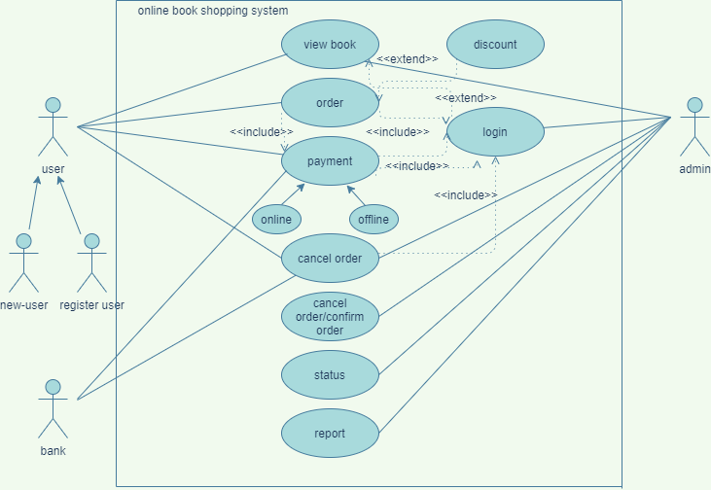

**(J). Draw usecase on Online shopping product using COD.**

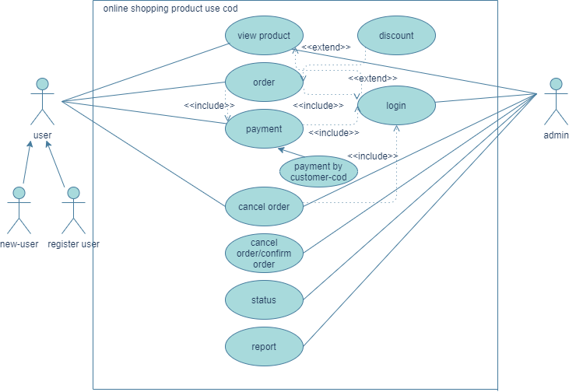

**(K). Draw Usecase on online bill payment system (paytm).**

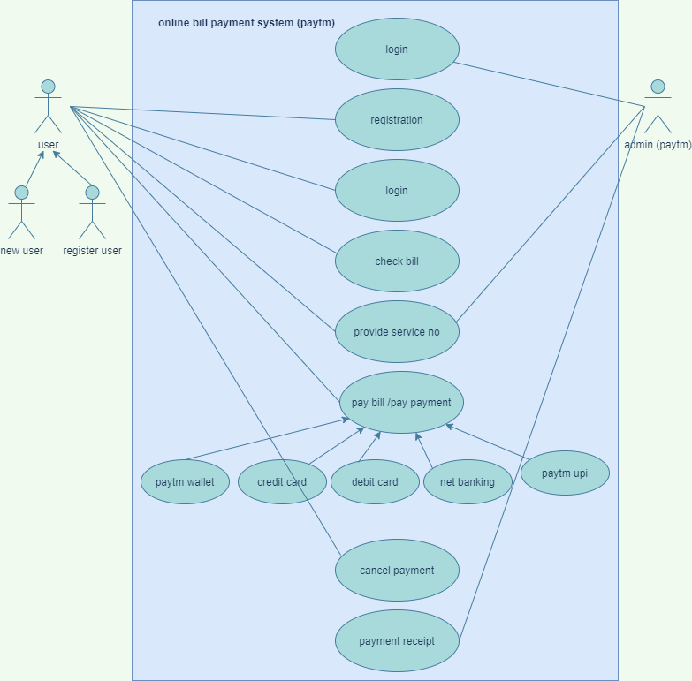

**(L). Draw usecase on Online shopping product using payment gateway.**

